AIR MONITORING SYSTEM

Technical Information

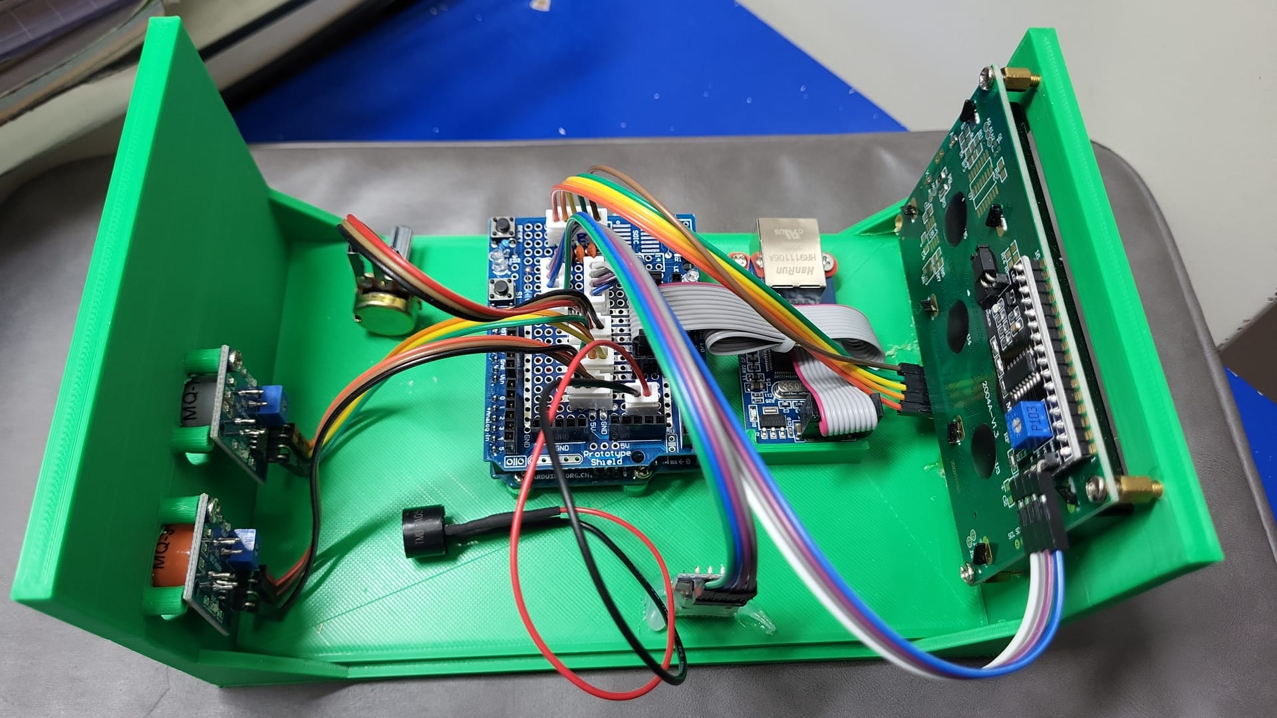

Index:

1. Idea of the Project
2. Workflow of the system
3. Materials
4. 3D printing model
5. Wiring Concept Diagram
6. Parts of the device
7. Notes on usage
8. Source code
9. Idea of the Project

In the Sustainable development goal, we would like to solve goal3, subgoal 9, which is to reduce illnesses and death from hazardous chemicals and pollution, so we would like to design a product to avoid accidents from toxic gas poisoning.

We would like to develop a system that keep on monitoring the presence of a certain gases and give warning to people. If a certain gas is detected, the device will send warnings to people around it and users can check the exact concentration of the gas in the air through a system.

1. Workflow of the system

1. Materials

Arduino Board system

1. Arduino Uno
2. W5500 ethernet shield / W5100 ethernet module
3. 2004A LCD display
4. IIC module for 2004A LCD display
5. MQ-series sensor (any 2)
6. Potentiometer (If needed for testing)
7. Buzzer
8. Jumper wires
9. HC-06 Bluetooth module
10. Type A to Type B wire
11. Ethernet cable
12. 3D printed case
13. M3 screw x12
14. 3D printing model

1. Wiring Concept Diagram

1. Parts of the Device

1. Notes on usage
2. Function of Buttons

1. Sensitivity of the sensor

You may change the sensitivity of the MQ-series sensor by turning the ‘Variable Resistor’ at the back of the sensor (the blue one).

1. Connection to bluetooth

The app created for connecting to the bluetooth module is NOT capatible with device using android 12 or later.

1. Bug

If the LCD display shows unknown characters or other bugs occurs, press the fourth button to reboot the system to solve the error.

1. Ethernet Issues

If you see that the local website shows that Ethernet has been disabled, that means the user did not allow the system to send data to the website. To solve this, press the first button to enable it.

1. A regular testing of system is recommended
2. Source Code

Visit this website : <https://github.com/Danielc3388/AirMonitor/blob/main/maincode/maincode.ino>

**Versions:**

First Version, Published on 19 May 2023

Second Version, Published on 8 July 2023

Third Version, Published on 10 August 2023